Book Interface

Project Analysis/ Design

Sabrina Kabir

February 23, 2026

Project Analysis

General Background:

The Book Interface is designed to assist users minimize their searching time when it comes to finding information on a specific book. With an array of information being present at the tip of their fingers, users can utilize this website to seek multiple information about a book. Book title, summary, author’s name, price are a few examples of what the information might entail. This reduces the number of tabs being open to find information about multiple books at once.

Construction of the Interface:

The main elements of the interface will include three different search options: book title, author’s name, and a general subject of books. It is important to note that the user will not need to input information across all three fields. However, one of the fields must have a value in order for the interface to function.

Analysis and Design

Technical Specification:

Once the user decides to input their data in one of the three fields, the system will generate API calls to OpenLibrary. The OpenLibrary will return the value as a JSON format, which will be coded further to display a list of books. Once the values have been retrieved through the API calls, the website will display at least 3 different books. The user will then possess the option to look into a book for further information. The book will display general information such as image of the book’s cover, summary, author’s name, and price. If the interface cannot return a value from the OpenLibrary API, the program will display an error message to the user. Possible errors for the APA calls can be server errors for OpenLibrary, inputting too many requests at once, or receiving a note that data that may not exist.

This formatting may vary based on the user’s input. If the user decides to search the interface with the author’s name, then the search results will list around 3 different books that the author had published. However, if the user opts to search through the general subject category then, the search results will display books based on the inputted category. Searching by the book title will return at least 3 books with the same title (if applicable), however, the books may not be written by the same author.
Errors on the interface such as not inputting a value in any of the three columns or not receiving a value through the API calls will be noted in the interface as an error message. This allows users to understand why the interface ceases to function.
This interface will not store data from past searches. It is also imperative to note that the interface will require a working internet connection to function, since the project will be developed through the Github environment.

Interface Design:

The main interface will be illustrated as:

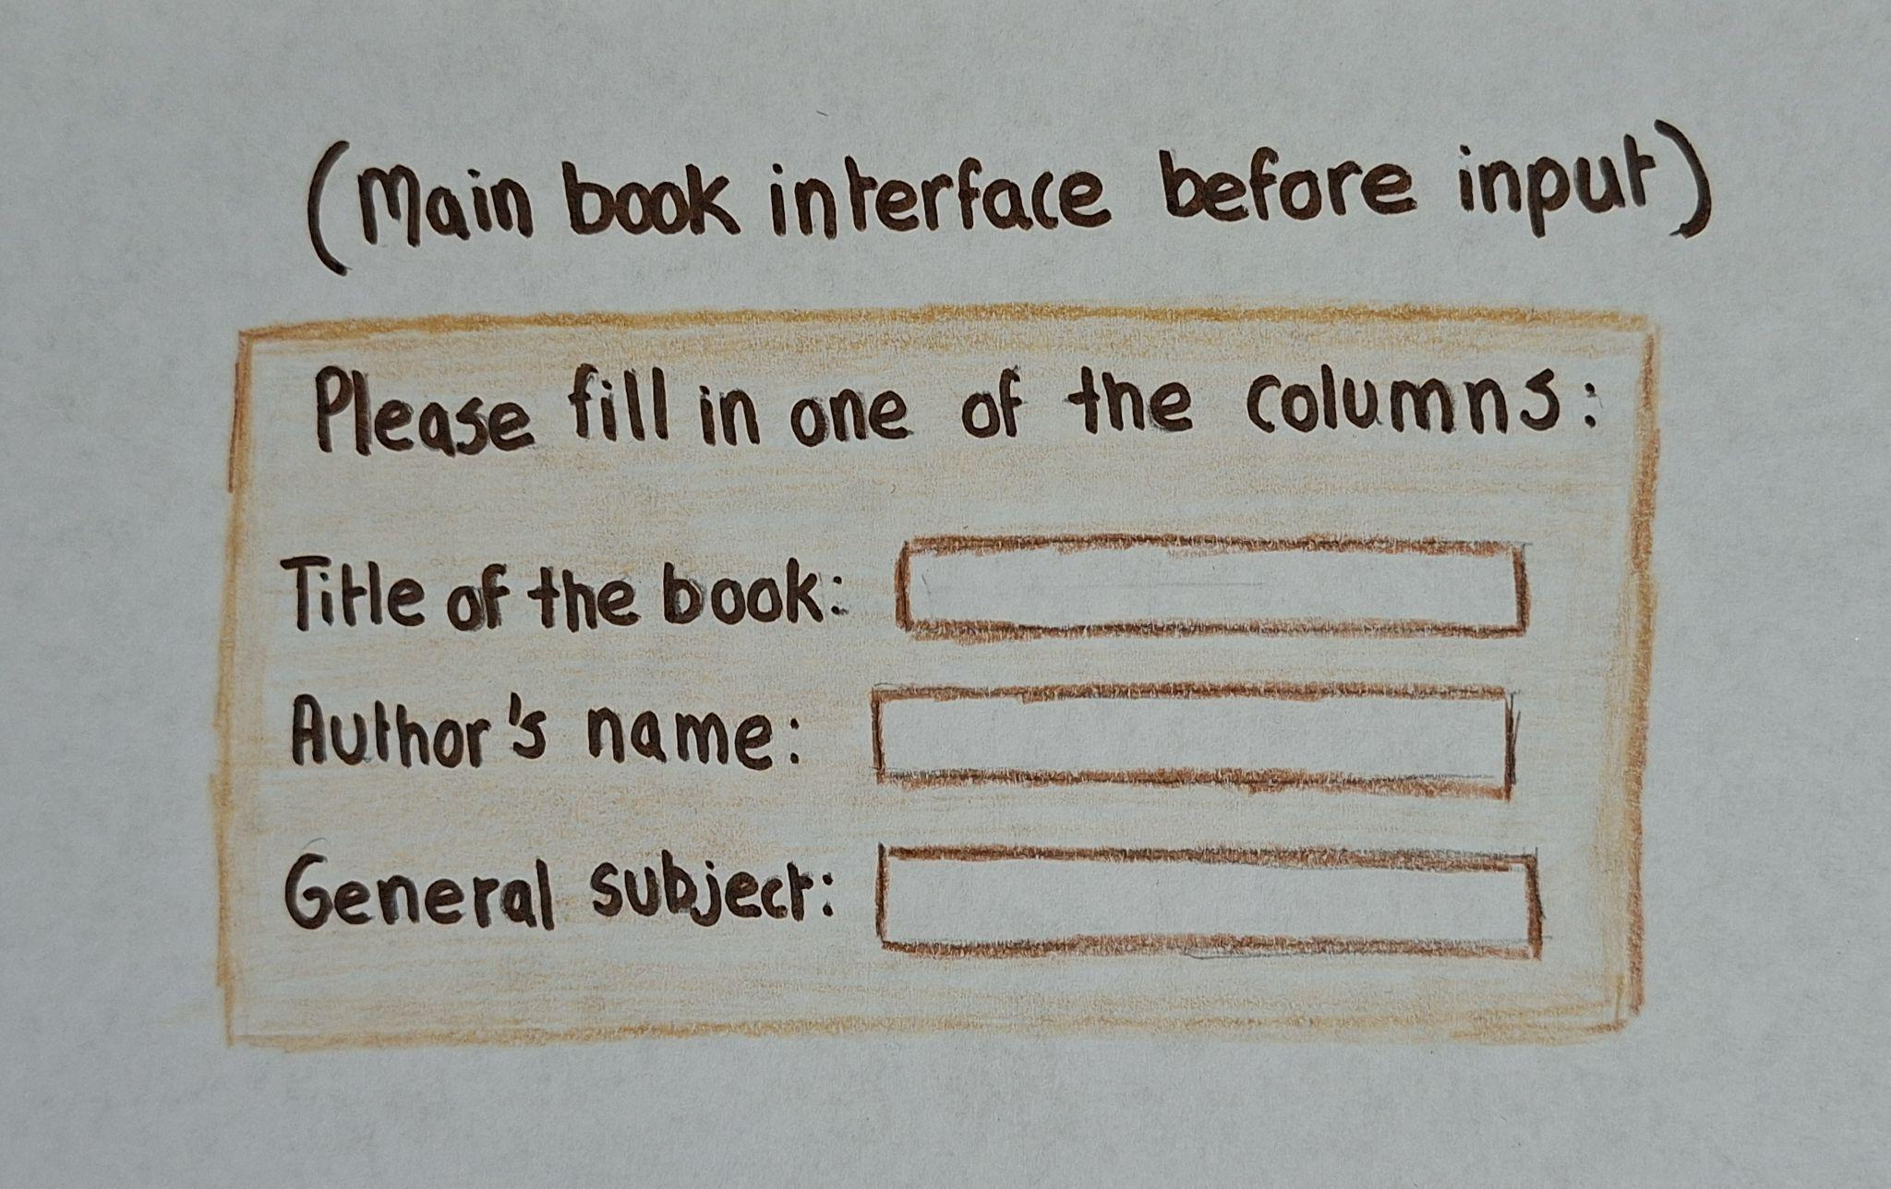

This is an example of what the interface would look like if the user has decided to input a book title in the title of the book column:

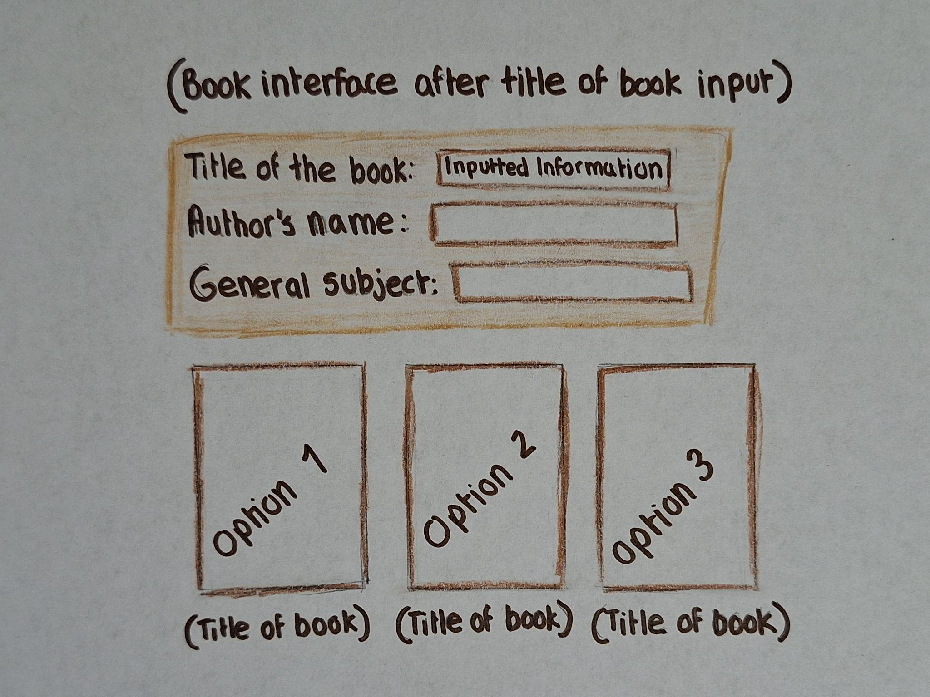

Entity- Relationship (ER) Model:

An entity-relationship model is constructed to showcase how each data from the interface correlates to one another.

